To search by topic
- Login to the OMA
- On the search bar make sure you select Official Methods of Analysis…
- enter your topic in the search box
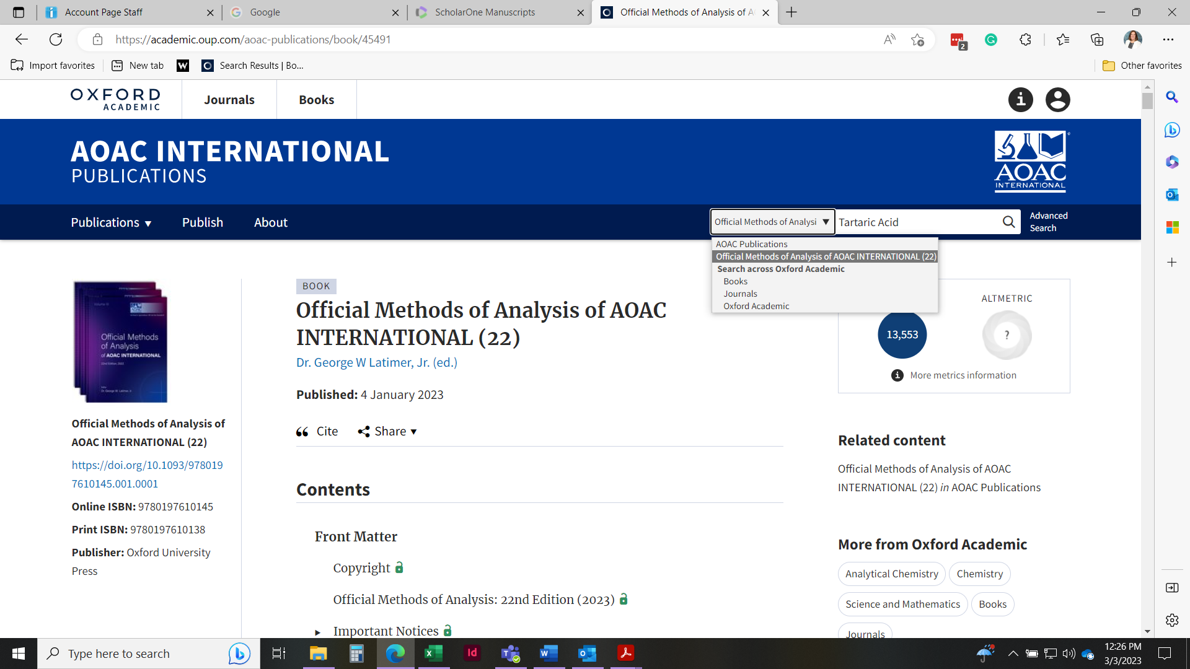

Click on the Chapter Baking Powders and Baking Chemicals

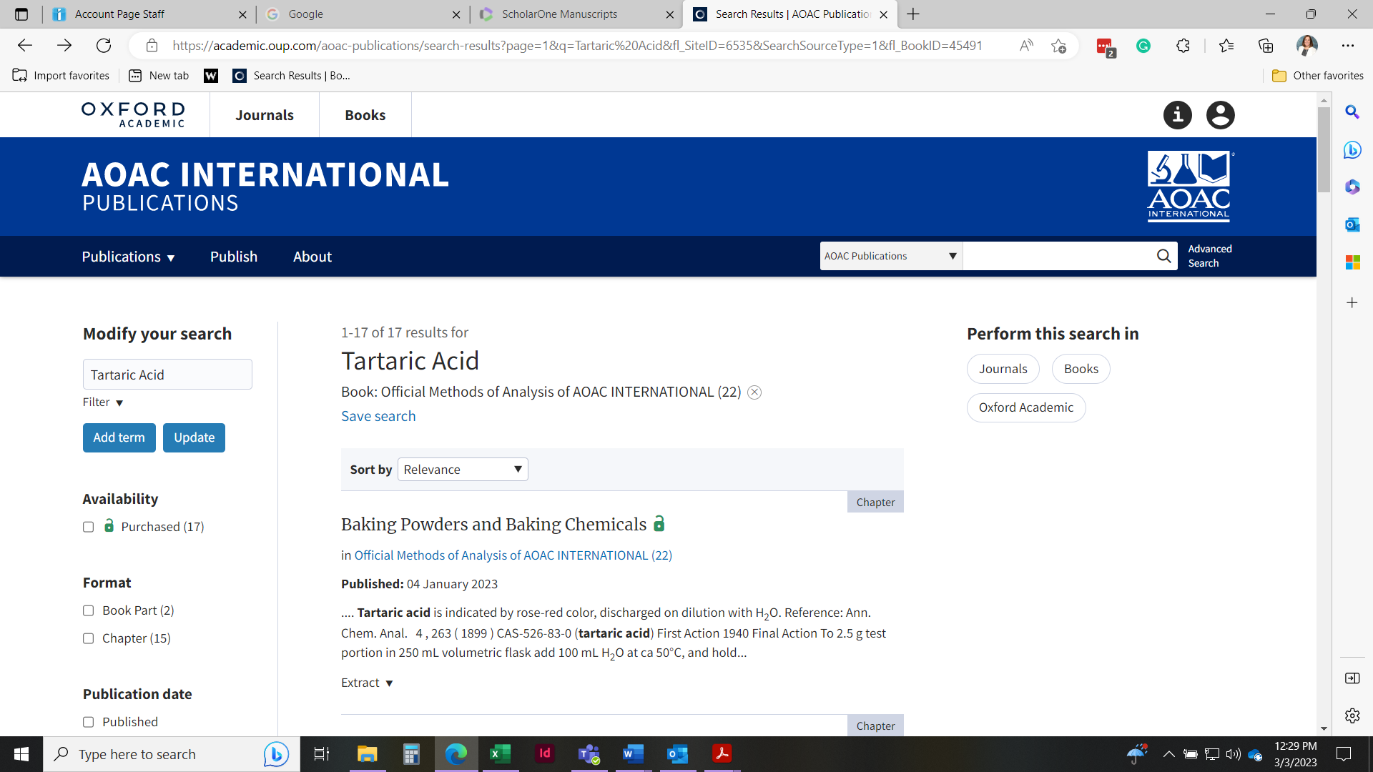

Once in the Chapter click on Split View.
Look in the panel on the right and, click on the arrow next to the chapter that will show you all the method titles in the chapter and subchapter.
(see next screenshot) When you find the method you want, click on it (for example scroll down to 899.01 in Chapter 25) Click on the method and it will appear in the window on the left
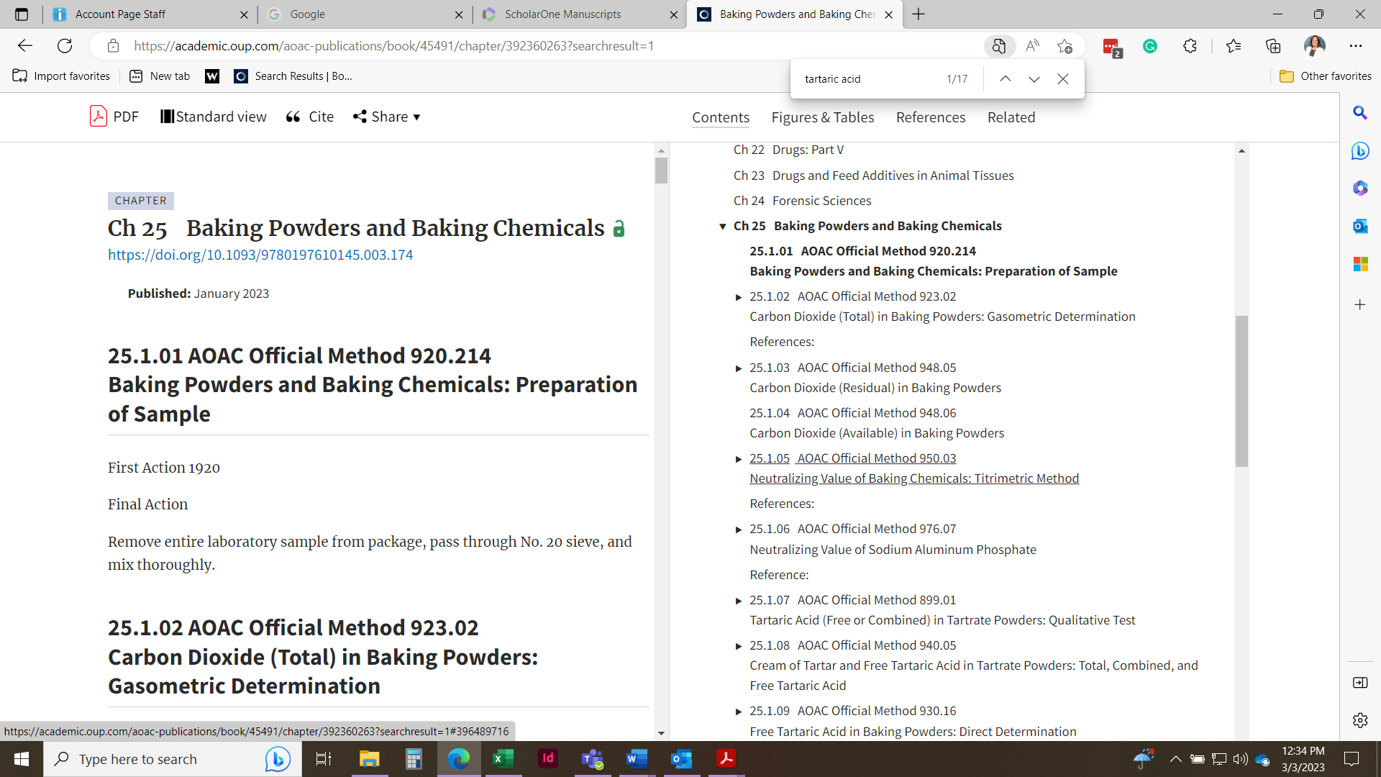

If you want to see the method in full screen click on Standard View
