1) Login to the OMA by clicking on the icon of the person in the upper right.
2) If you have a method number the easiest way to search is through the Index of Method Number. This is located in the End Matter under Index scroll way down through the Subject Index until you see index of Method Number. Locate your method number in the list. (i.e., Method 899.01) the numbers following the method number indicates Chapter, Subchapter, and where it is positioned in the chapter/subchapter (25.1.07) meaning the method is located in chapter 25 subchapter 1 and it is the 7th method in the subchapter. (see screen shot 1)
3) To the left of the Index you will see Contents. Use the slider bar and navigate to Chapter 25 and scroll down until you see 899.01 and then click on the method title (Screen shot 2).
4) Another option is to use split screen (see screen shot 3). Go to Endmatter click on Index click on Split view. Note in the screen shot how far down I had to scroll (drag the bar) to get to the number index. OUP is working on splitting up the indexes, so they are not so cumbersome. When you use split view you will notice that all the chapters are on the right side of the screen which has better visibility then the Content pane on the left. When you click on the chapter it will go back to the Standard View.
See screenshots on the following pages.
Screenshot 1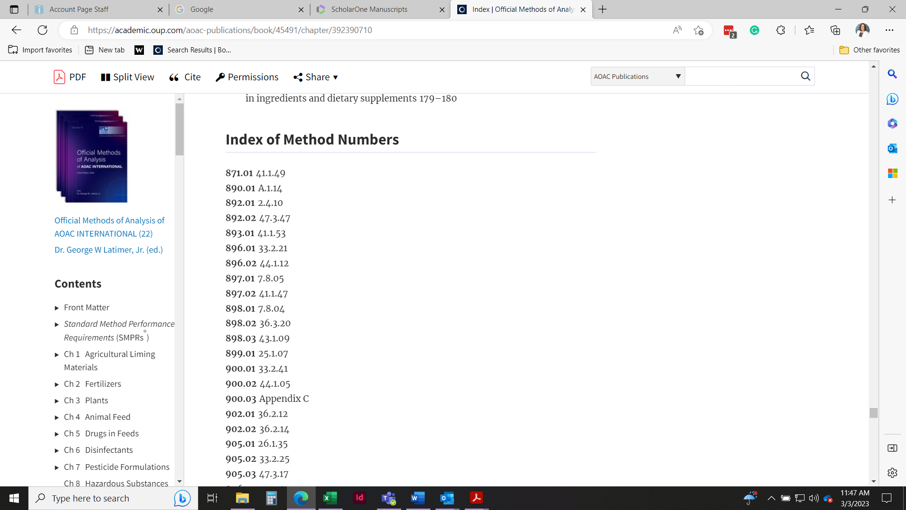

Screenshot 2
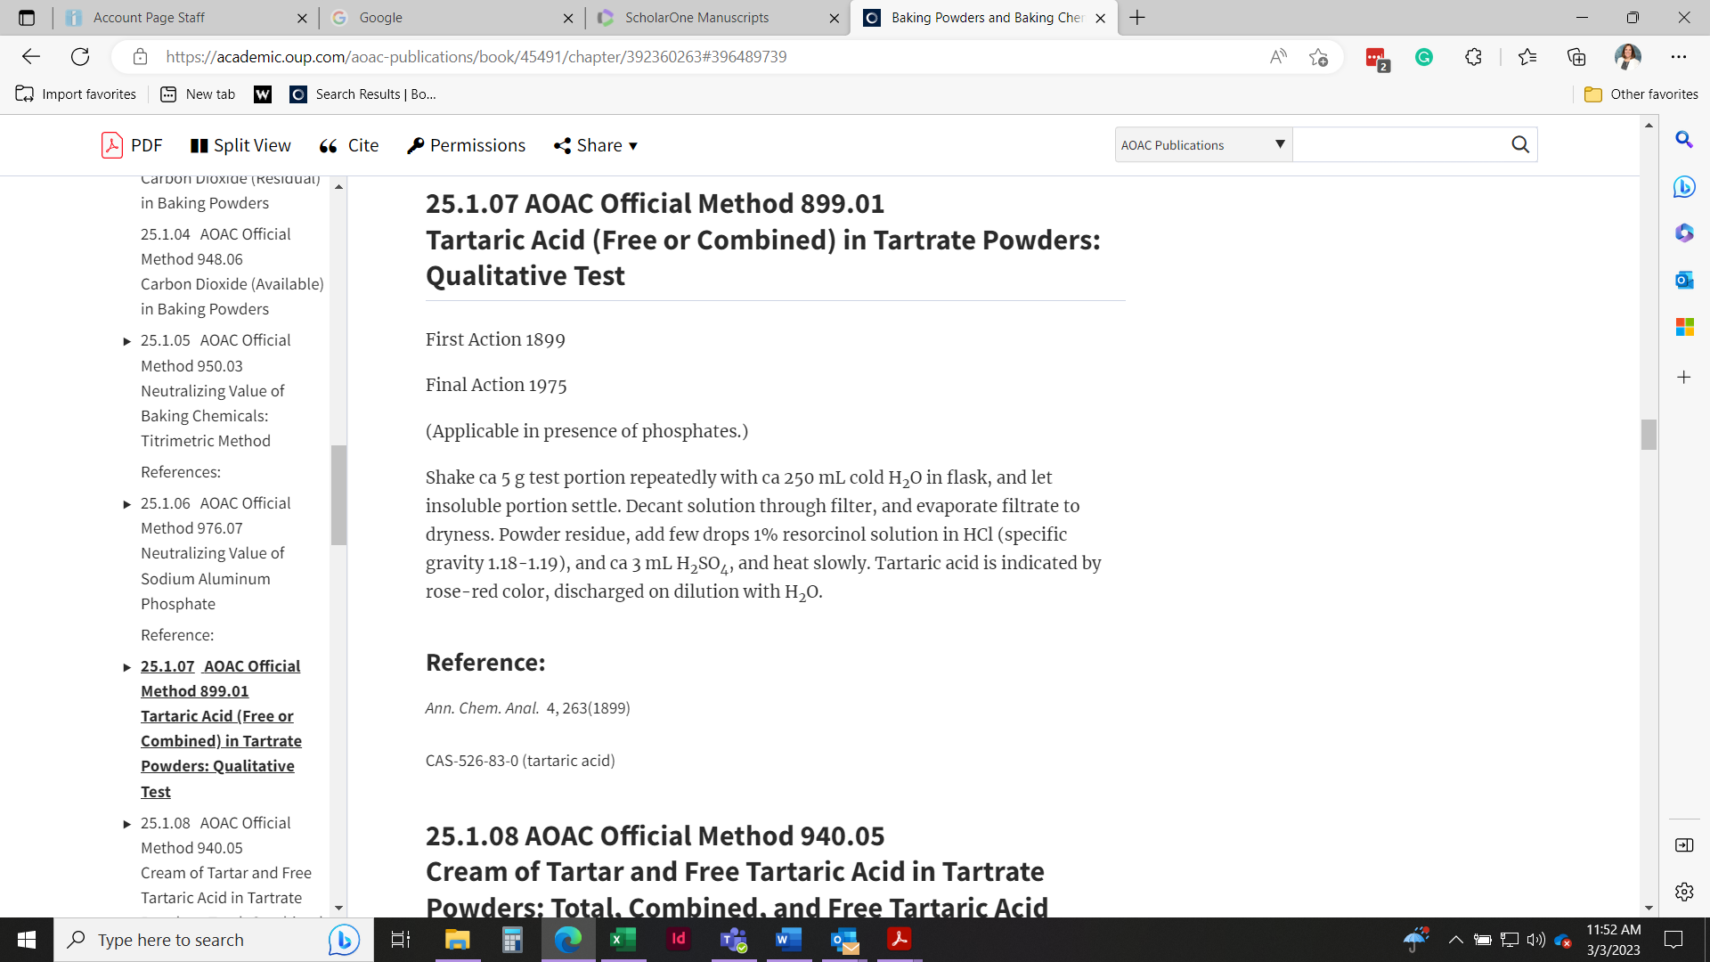

Screenshot 3 using Split View
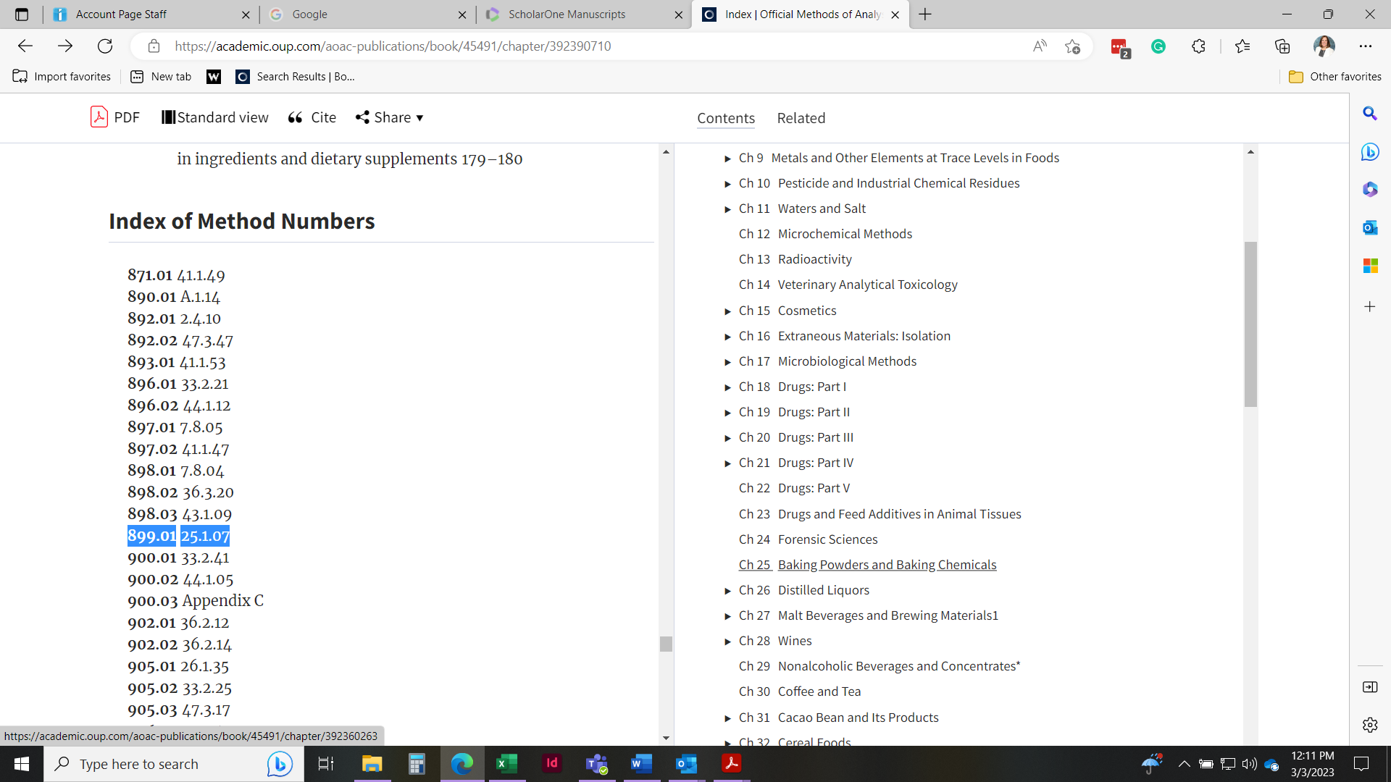

Click on Chapter 25 in the split view and then scroll down to 899.01
